<https://github.com/CristinaBors/HW_UX_UI/blob/main/prod/appico-features/features.html>  
<https://github.com/CristinaBors/HW_UX_UI/blob/main/prod/appico-features/features.css>  
  
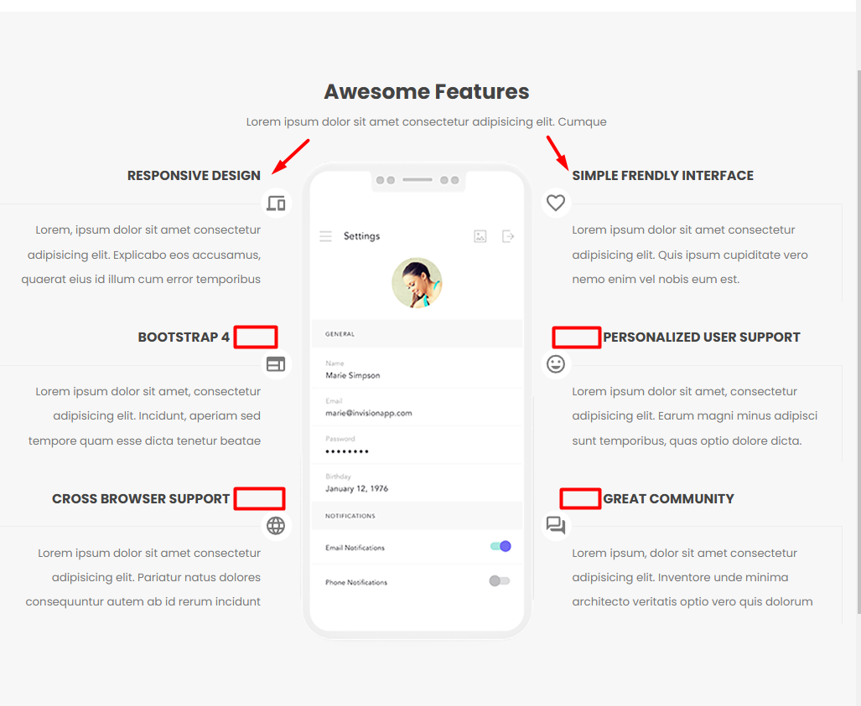  
10.12  
<https://github.com/CristinaBors/HW_UX_UI/blob/main/Lesson%2020/V1/does.css>  
<https://github.com/CristinaBors/HW_UX_UI/blob/main/Lesson%2020/V1/dose.html>  
  
